CrackMe Assignments
CRACKME0x05
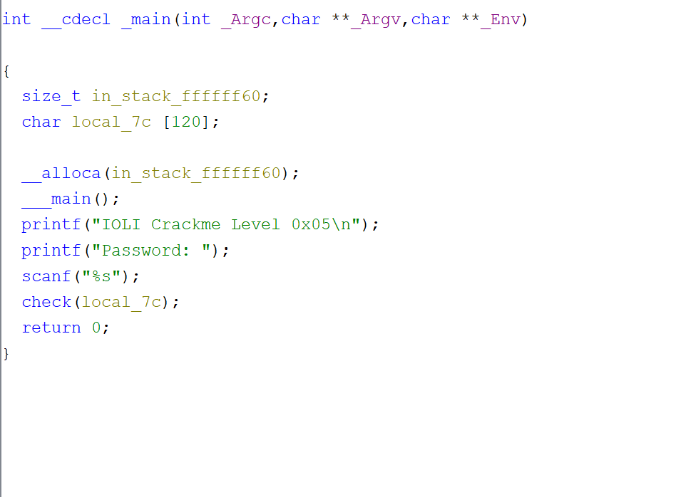
- It reads your password input as a string and passes it to check(local_7c).

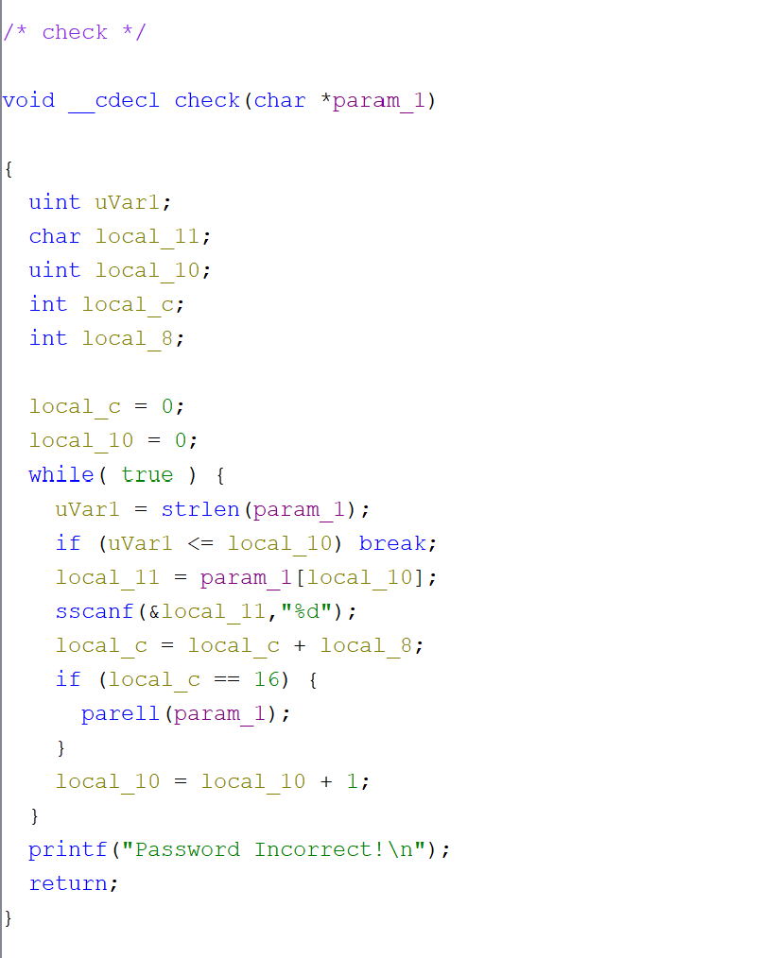
- Check for the sum to equal 16.
- If true, it forwards the param_1 to parell.
- If the sum hits 16 but the number is odd, parell returns, the loop ends, and check() prints “Password Incorrect!”.

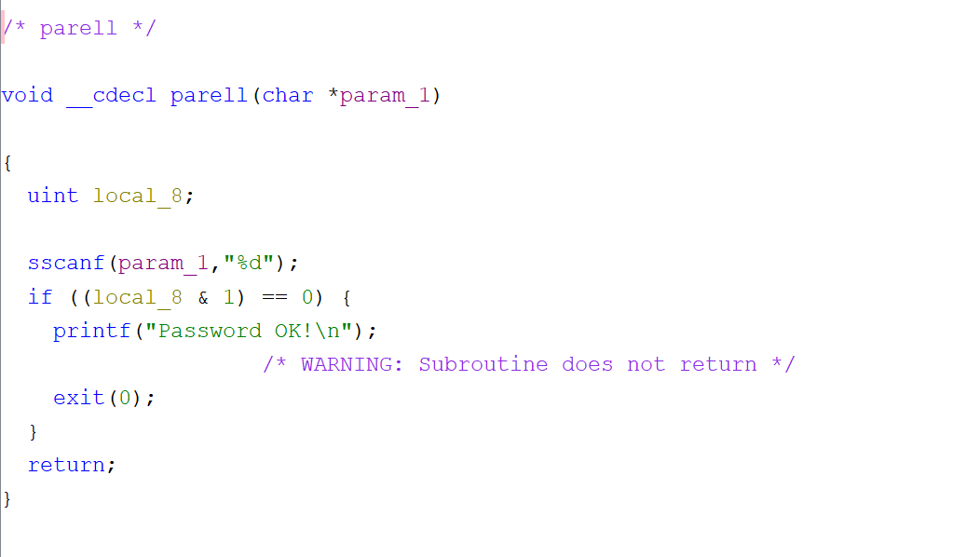
- This function checks whether the entered number is even ((local_8 & 1) == 0).
- If it’s even and equals 16, it prints “Password OK!”

CRACKME0x06
**This is the same as crackme0x05, but with a twist to it.**
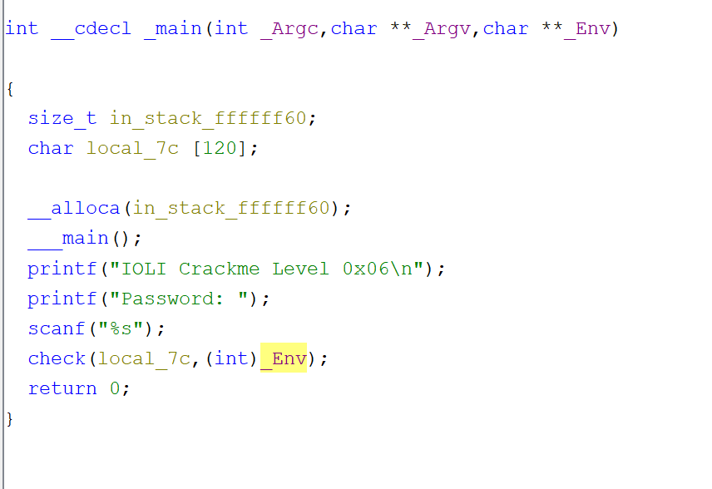
- This is the main entry, however an _Env is added to the check function.
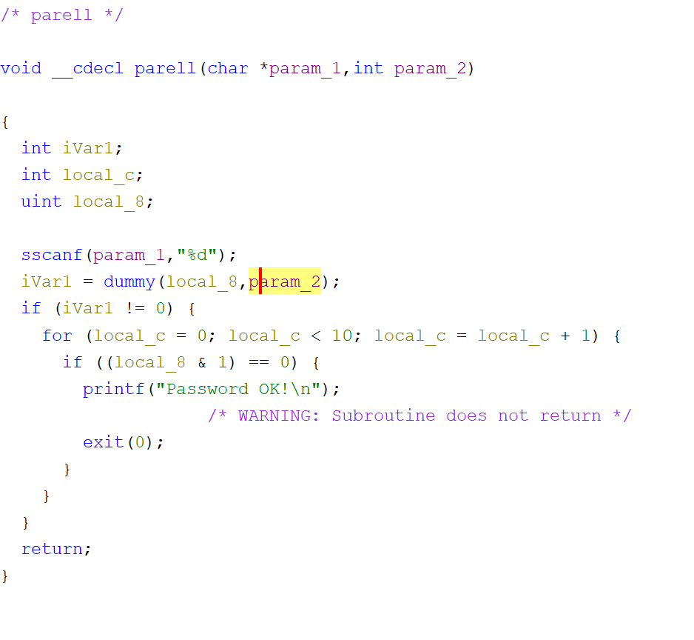
- Found the password OK section to see what I need to do and spotted a dummy function

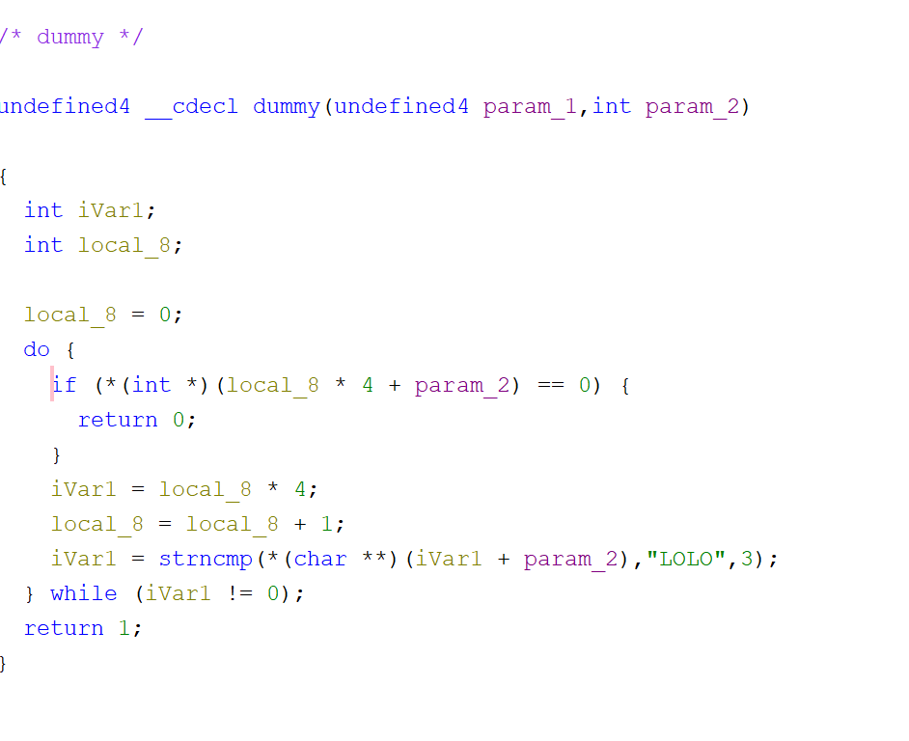
- The dummy code requires you to have an environment set up and run the crackme0x06. Just like crackme0x05 the requirement needs to be even numbers that equal to 16.

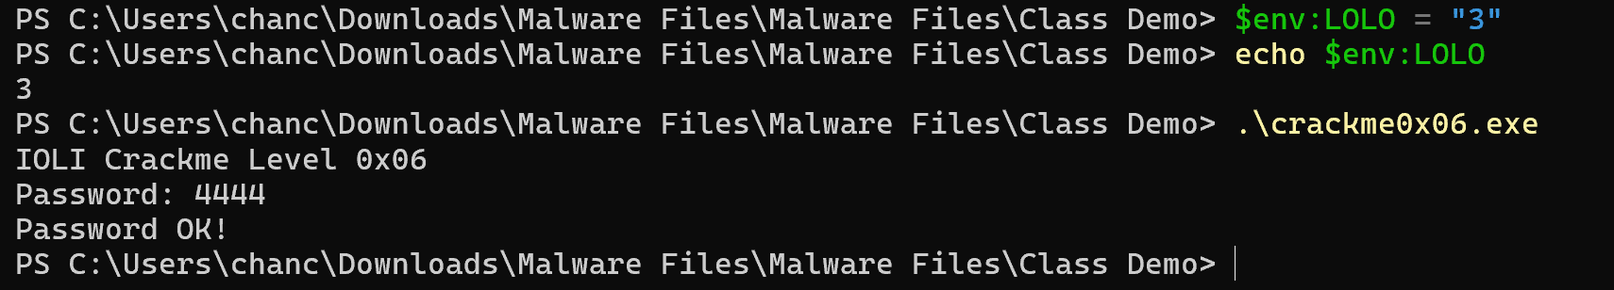
- This is the setup used for me to figure out the crackme assignment.

